...
The Ministry of Education
First Exam
Name: ........................... . Class: 3 Th Grad
★ Write the missing letters

a | b | c |  | e | f | g |  | i | j

k |  | m | n | o |  | q | r

s |  | u | v | w |  | y | z
****************************************************************************************
★ read and match
These are | This is | That is
…………………………. ……………………………….. ……………………………………
Those are | This is | That is

…………………………. …………..……………… ………………..……………
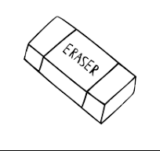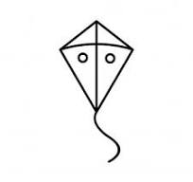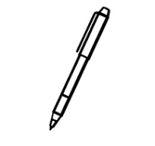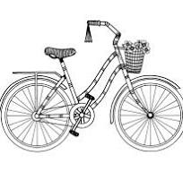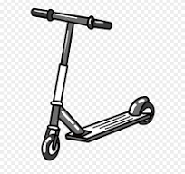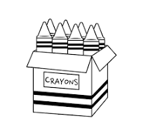
k_
rubber a scooter pen crayons kite bike

******************************************************************************************

Those are | These are | That is | This is

………………… ……..………….. ………………… ……...………

**************************************************************************************************
13 16 15 17 14

thirteen fourteen fifteen sixteen seventeen

******************
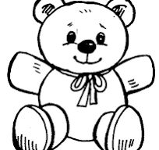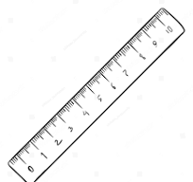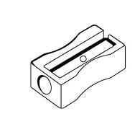

plane bear sharpener ruler
*****************************************************************************************************

Match :-

19 11 12 18 20

eighteen nineteen twenty eleven twelve

1 : What’s your name? …………………………………………….…
2: How old are you ? ……………………………………
3: How are you ? ………………………………………..
4: Where do you live ? ………………………………….

★ Look at the story. Read and circle.

1: We have don’t have art lessons.
…………………………………………………………
2:-You go don’t go to school.
…………………………………………………………
3:-We have don’t have tennis lessons.
……………………………………………………………

