Marka for Hearing Impaired
Students School
Name : ……………………………. 1st semester 2025-2026 Date: / /2025

First Exam /Second Grade
Name_____________________________________________________
- What’s your name ? My name is ________________ (1mark)
- How old are you ? I’m ____________ (1mark)

Q1:Write the names of these things under their pictures: (5marks)
( scooter / swing / building set / puzzle / robot )
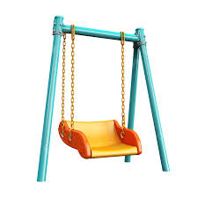

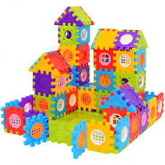


________________ ________________ ___________________
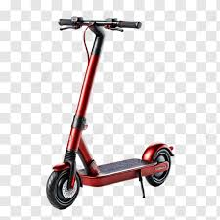

__________________ ___________________

- Q2: Put ( a ) or ( an ) in space: ( 3 marks)

- It’s ______ robot .
- It’s ______ action figure.
- It’s ______ doll.

Q3:Ask and answer : ( 4marks)
Yes, it is No, it isn’t

- Is it a bike?
_________________________
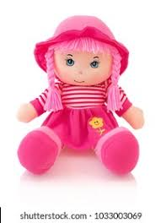
- Is it a swing ?
_________________________

- Is it a teddy?
_________________________
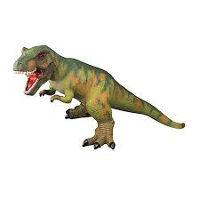
- Is it a dinosaur ?
_________________________

Q4: Read and color: ( 5 marks )
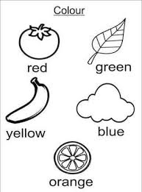
Q5: How many ? Count : ( 6 marks)
